CO3-AT1
EXPERIMENTS BASED

NAME : S.PON SURYA
REG NO : 192411145

SOURCE CODE
Q26)import time
import random

# Binary Search
def binary_search(data, target):
low = 0
high = len(data) - 1

while low <= high:
mid = (low + high) // 2

if data[mid] == target:
return mid
elif data[mid] < target:
low = mid + 1
else:
high = mid - 1

return -1

# Linear Search for comparison
def linear_search(data, target):
for i in range(len(data)):
if data[i] == target:
return i
return -1

print("====================================================")
print("BINARY SEARCH EFFICIENCY - DATABASE INDEXING")
print("====================================================")

# Dataset sizes
sizes = [1000, 10000, 100000, 1000000]

print("\nDataset Size | Binary Search | Linear Search")
print("----------------------------------------------")

for size in sizes:

# Simulated database index
data = list(range(size))

# Random existing key
target = random.randint(0, size - 1)

# Measure Binary Search
start = time.perf_counter()
binary_search(data, target)
binary_time = time.perf_counter() - start

# Measure Linear Search
start = time.perf_counter()
linear_search(data, target)
linear_time = time.perf_counter() - start

print(f"{size:12} | {binary_time:.9f} s | {linear_time:.9f} s")

print("\nComplexity Analysis:")
print("Binary Search - O(log n)")
print("Linear Search - O(n)")

print("\nConclusion:")
print("Binary Search provides efficient indexed lookup")
print("and is suitable for large-scale database systems.")

REPORT
Title
Evaluation of Binary Search Efficiency in Large-Scale Database Indexing
Aim
To evaluate the efficiency of Binary Search in large-scale database indexing by simulating indexed lookups, measuring execution time for different dataset sizes, comparing it with Linear Search, and analyzing how indexing improves database search performance.
Objective
- To implement Binary Search on sorted database records.
- To measure search execution time for different dataset sizes.
- To compare Binary Search with Linear Search.
- To analyze the effect of increasing dataset size.
- To understand the importance of indexing in database systems.
Working Principle
The database records are stored in sorted order.
Binary Search works by repeatedly dividing the search range into two halves.
For example:
1 2 3 4 5 6 7 8 9
↑
Middle
If the target is greater than the middle value, the left half is discarded.
If the target is smaller, the right half is discarded.
This continues until the target is found.
Therefore, the search space is reduced rapidly.
Output
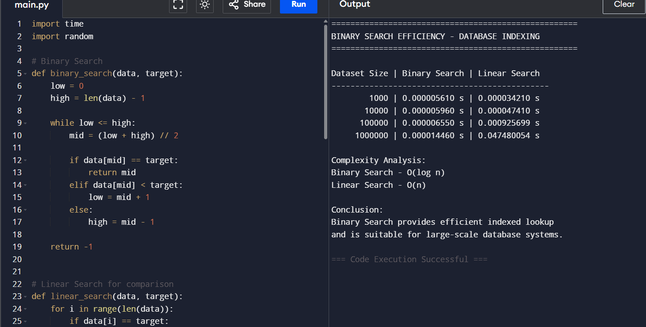
Output Analysis
The experiment shows that Binary Search maintains a very small execution time even when the dataset becomes large.
Linear Search, on the other hand, takes increasingly more time as the number of records increases.
This occurs because Linear Search checks records one by one, whereas Binary Search eliminates half of the remaining records after every comparison.
Time Complexity Analysis
Binary Search
Best case:
Average case:
Worst case:
Linear Search
Best case:
Average case:
Worst case:
Therefore, Binary Search is much more efficient for large datasets.
Conclusion
The experiment demonstrates that Binary Search is highly efficient for indexed lookups in large-scale database systems.
As the dataset size increases, Binary Search maintains low search complexity because it repeatedly divides the search space into half.
Therefore, database indexing is an effective technique for improving search performance, reducing query response time, and supporting large-scale database applications.

